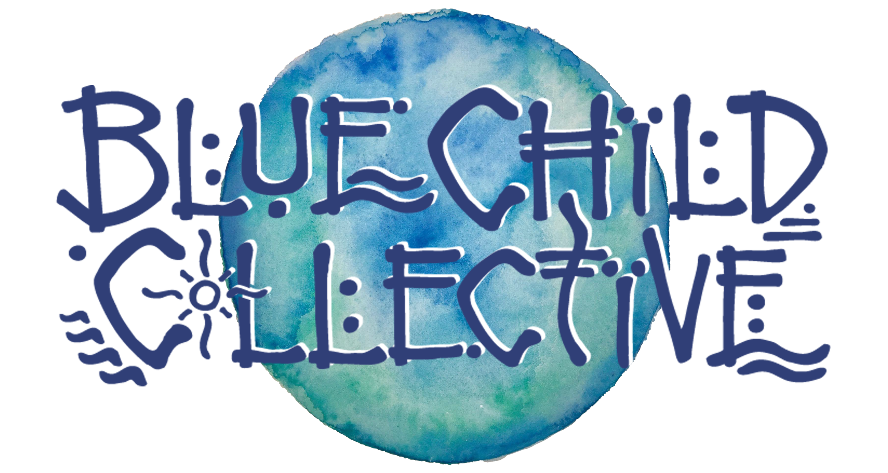

___________________________________________

- New Single, Music Video & WA-NZ Tour -

_____________________

Recently crowned West Australian Music’s Best Regional Act 2019, the conscious roots collab from Margaret River is powering into the new year with their new single “Golden”.

Set for release January 17th, the track is a quick follow up to the release of the group’s third documentary, titled “The Art Of Sound” in November, and paves the way for the release of two more singles and their fifth studio album later this year.

Written on a Mt Maunganui sunrise while on tour in New Zealand, “Golden” sees Blue Child Collective exploring new sounds, blending elements of indie folk and roots to produce a track in a similar vein to “Crosses” by Jose Gonzalez and Bon Iver’s smash hit “Holocene”, yet featuring a solid percussion bed, baritone vocals and clever group singalong “Harmony with everything // Harmony, we all can sing in (rpt)”.

The single will be accompanied by a music video shot on Super 8 film due to drop in February, and will see the group back across to New Zealand for a run of headline shows and festivals following the WA launches.

Band leader and director of The West Australian Guitar Festival Dan White said he’s really excited for the year ahead; it feels like all the work we’ve been putting in touring to connect with our audience and the huge focus we’ve put on content creation in order to continue delivering quality and quantity to those fans over the last five years is coming together. There’s plenty in the pipeline for 2020.”

Plug in, connect and get involved: Blue Child Collective is more than a band, but a movement which is fast becoming a major catalyst for positive change on a global scale towards a “Culture Of Connection”.

Tickets on sale now.

www.bluechildcollective.com
@bluechildcollective
#cultureofconnection

Golden Launch Tour

Fri 17th Jan | The River | Margaret River, Western Australia
Sat 18th Jan | Mojo’s Bar | Fremantle, WA
Sun 26th Jan | SkyFest | Bunbury, WA
Fri 21st Feb | 4th Wall Theatre | New Plymouth, New Zealand
27th Feb - 1st Mar | NZ Spirit Fest | Waimauku, NZ
Thu 5th Mar | Paisley Stage | Napier, NZ
Fri 6th Mar | The Jam Factory | Tauranga, NZ
Fri 13th Mar | YOT Club | Raglan, NZ

Tickets on sale at www.bluechildcollective.com

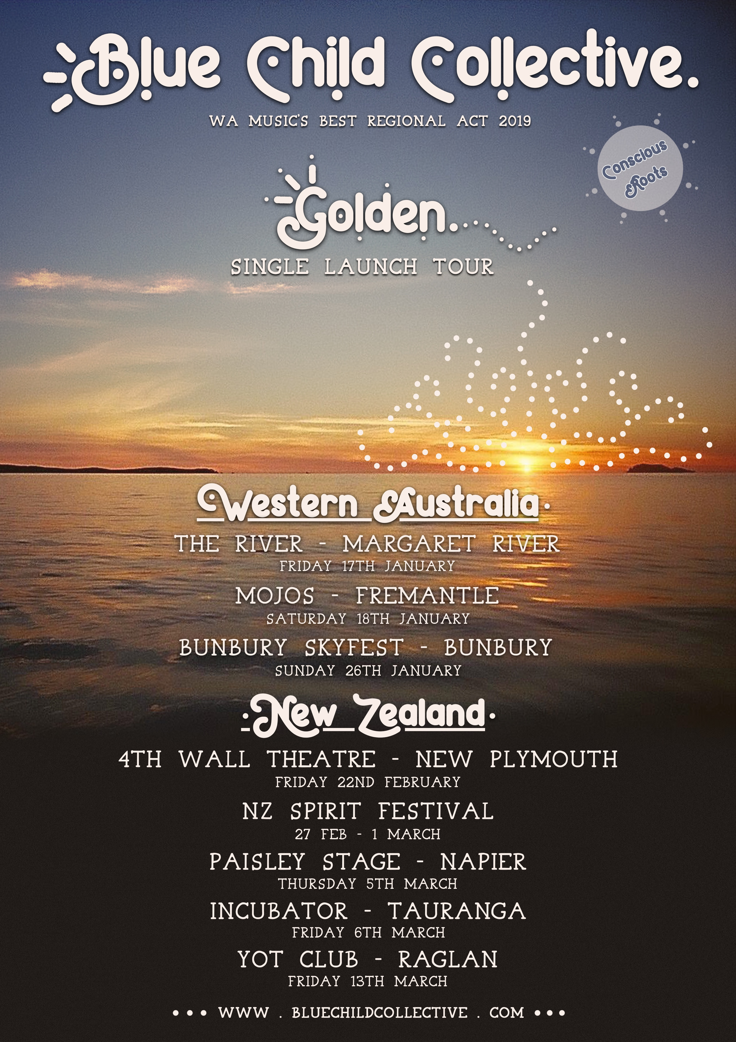
(@lescelleimages)

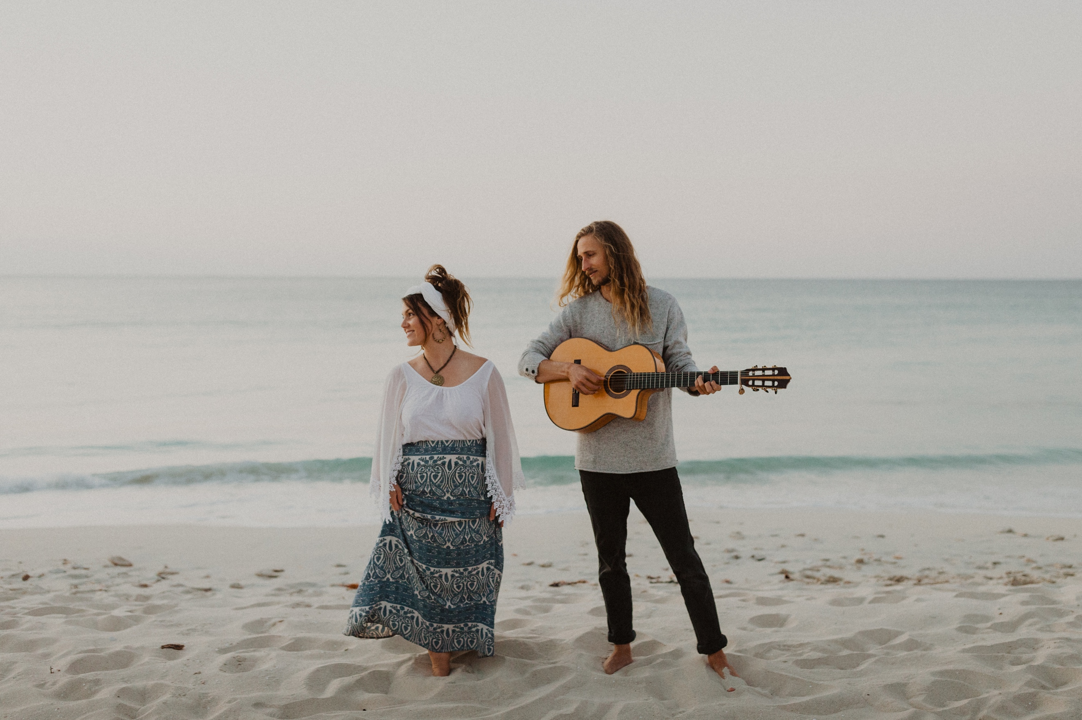
(@parishawkenphoto)

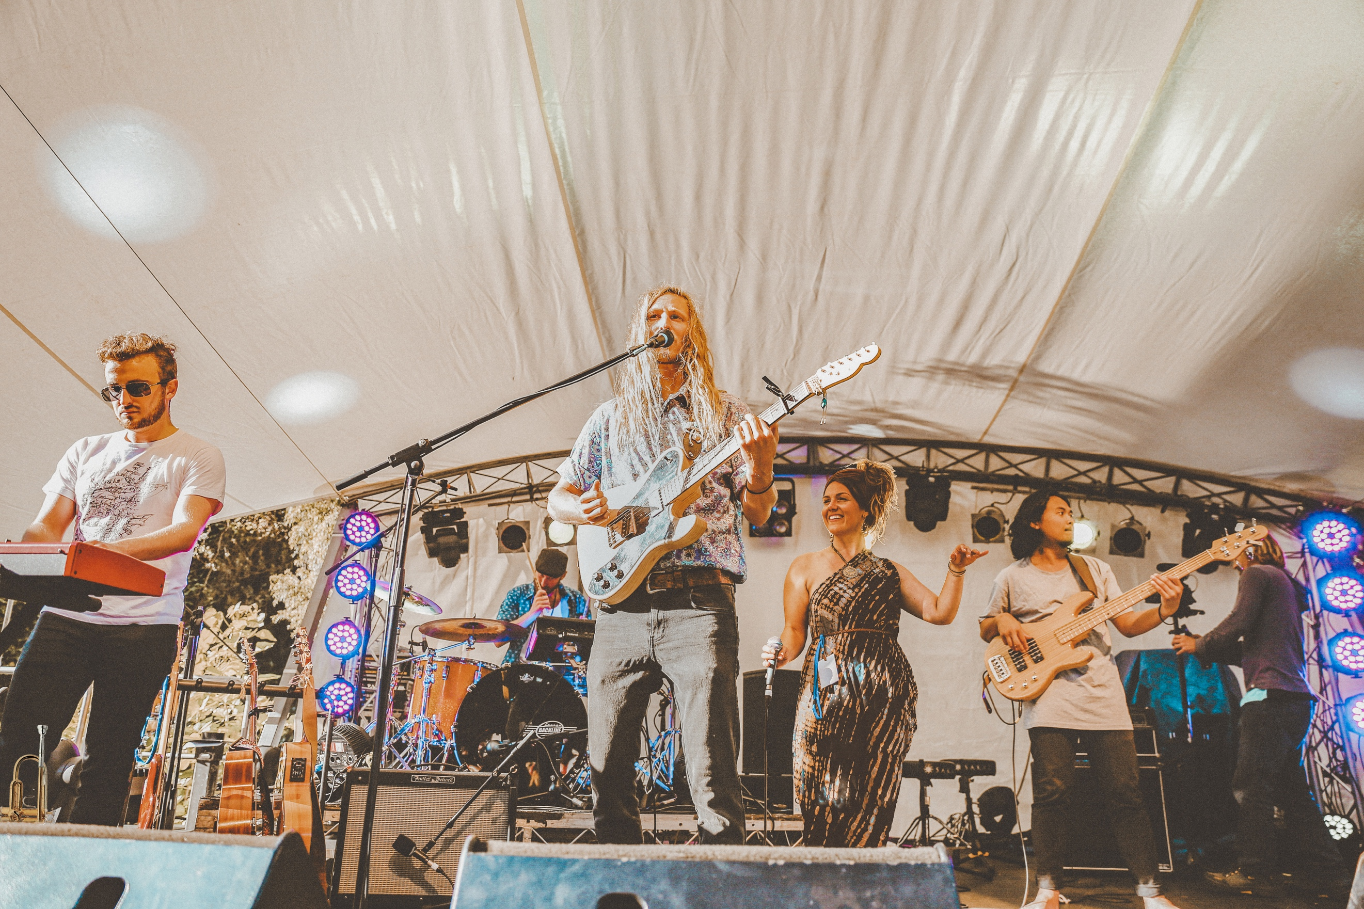
(@sarastormphotography)

