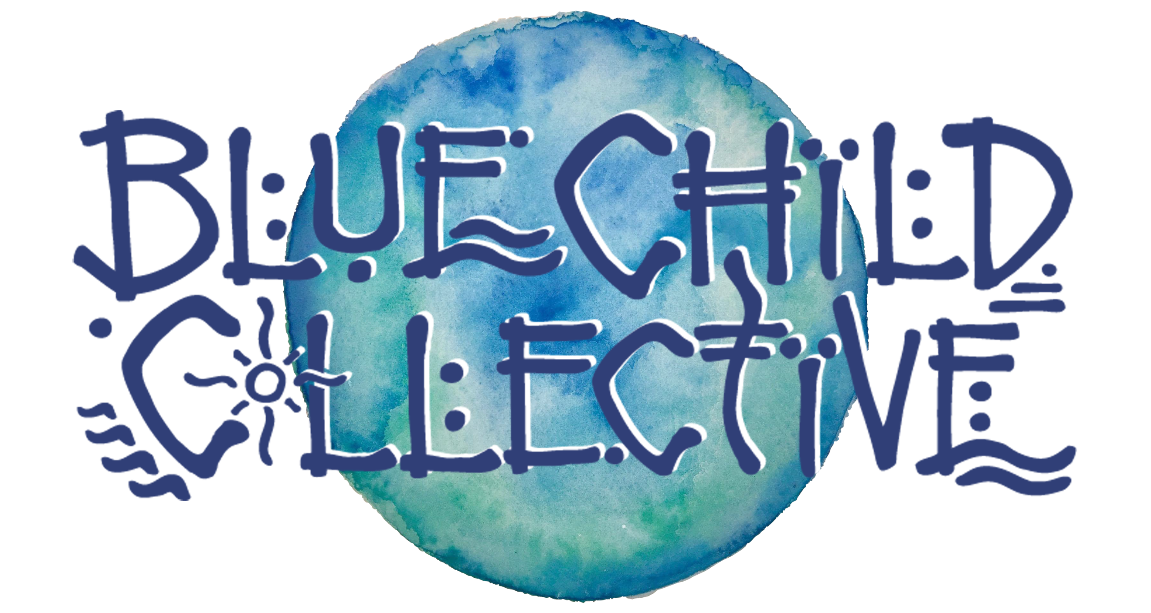

___________________________________________

- Culture Of Connection -

_____________________

Recently crowned West Australian Music’s Best Regional Act 2019, Blue Child Collective is a conscious roots collaboration born on the rugged coastline of Margaret River, Western Australia.

At its heart is Dan White, director of The West Australian Guitar Festival, prolific songwriter, keen producer and fingerstyle artisan who has a swathe of albums, documentaries, tours and more to his name. From his thought-provoking lyrics to the Collective’s engaging live performances, “Blue Child Collective is connecting people through music” (Scenstr), creating waves that have earned them supports for The Cat Empire, Xavier Rudd, Sticky Fingers, San Cisco, The Teskey Brothers and many more.

The Collective's fourth record, “Wake Up To The Sound”, released November 2018 and featuring an all class line up including OJ Newcomb (John Butler Trio), Bobby Alu, Ken Allars (Caravana Sun) and more has seen them build upon what is now hundreds of shows across Australia, New Zealand, Europe and Asia in the group’s 5 years of bringing both full band dance offs and stripped back solo/duo performances to a rapidly growing global following.

Having just released their third documentary, titled “The Art Of Sound”, in November, the Collective will be kicking off 2020 with the release of their new single “Golden” January 17th plus music video shot on Super 8 Film which will see the group across to New Zealand for a run of headline shows and festivals following the WA launch shows.

Plug in, connect and get involved: Blue Child Collective is more than a band, but a movement which is fast becoming a major catalyst for positive change on a global scale towards a “Culture Of Connection”.

www.bluechildcollective.com
@bluechildcollective
#cultureofconnection

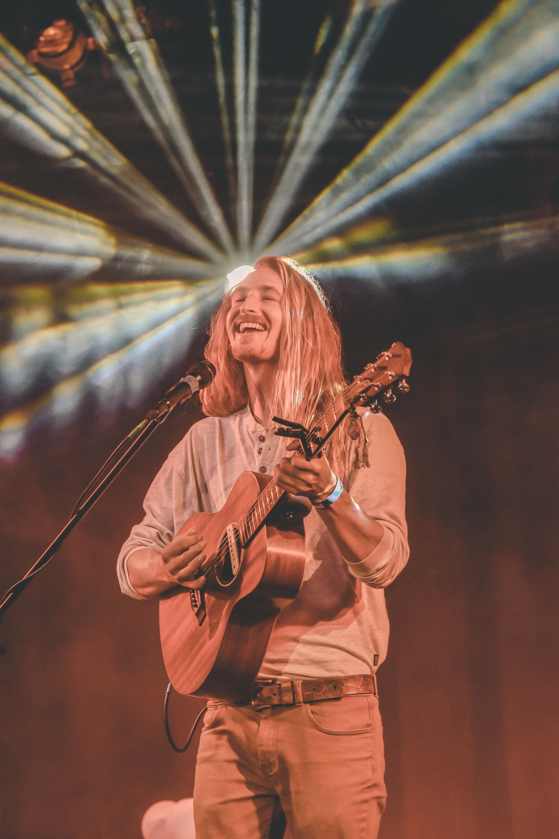
(@lescelleimages)

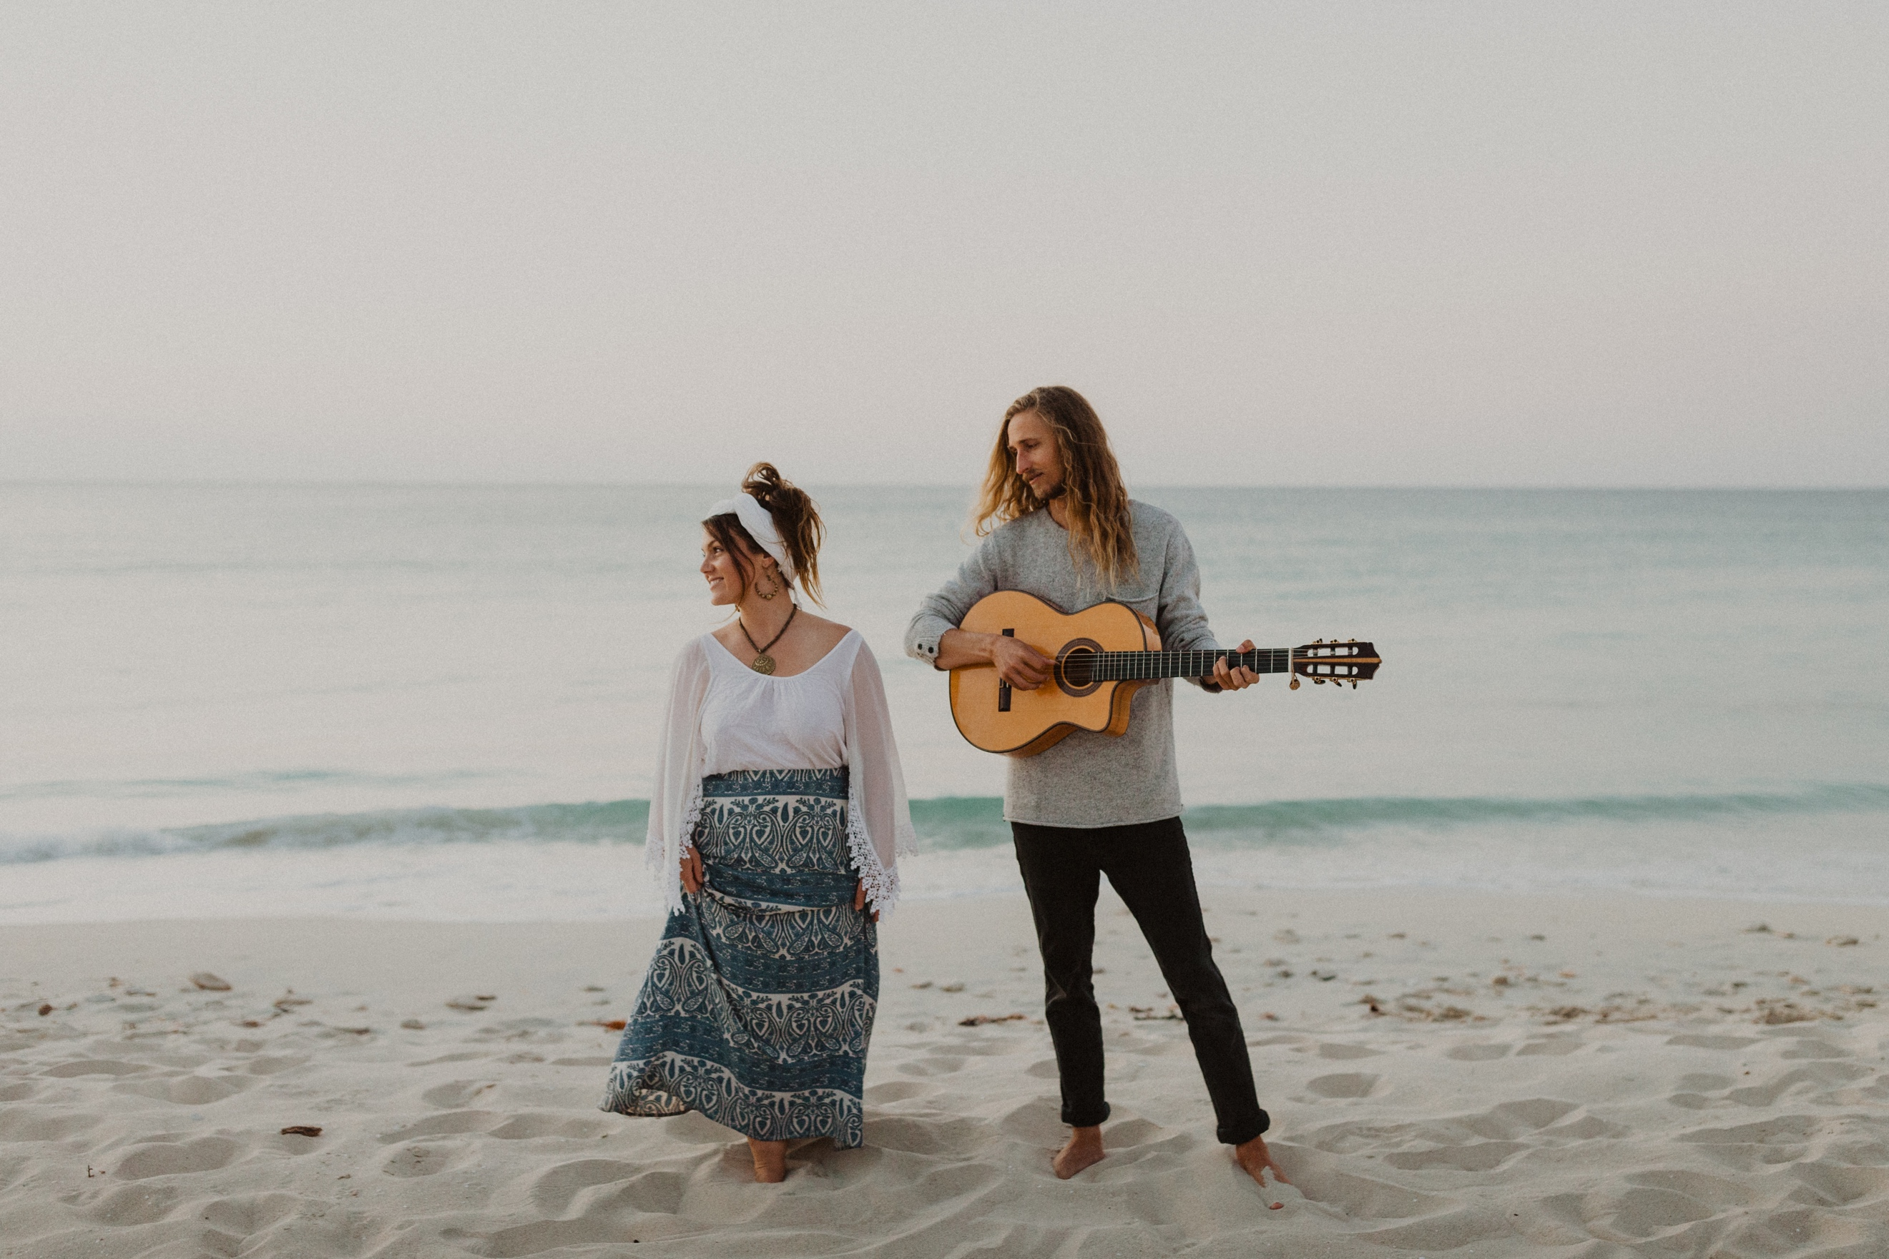
(@parishawkenphoto)

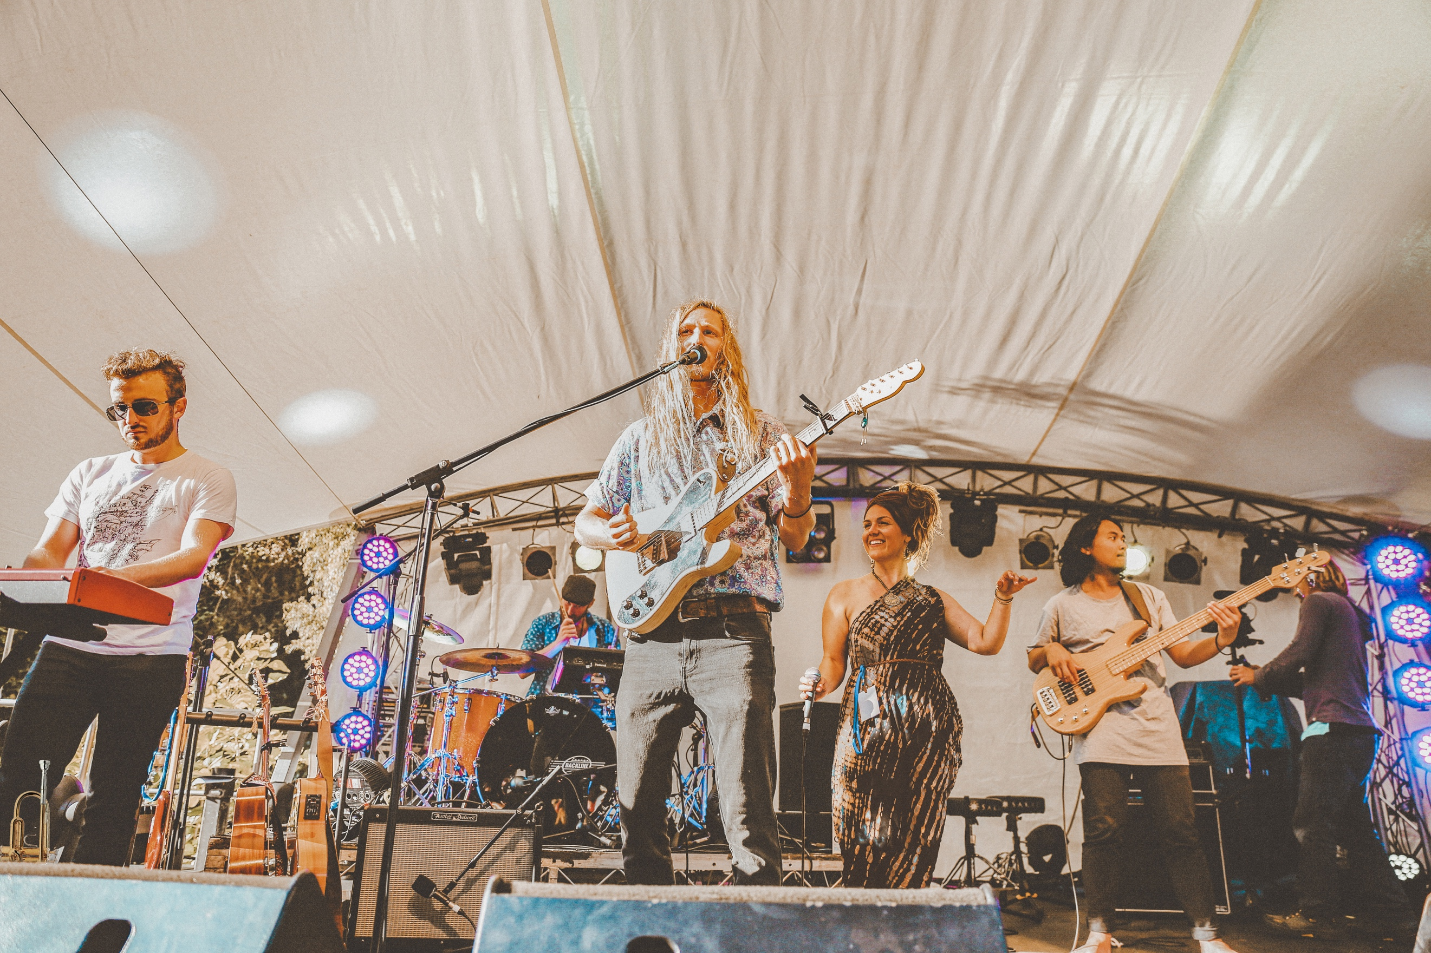
(@sarastormphotography)

